ØØ Explanation :
- Get the number in the accumulator from register B.
- Rotate the number 4 times to the right
- Store the shifted number back in register B
ØØ Algorithm :
Step I : Get the number in the accumulator from register B.
Step II : Rotate the number 4 times to the right.
Step III : Store the result in register B.
Step IV : Stop
ØØ Flowchart : Refer flowchart 26.
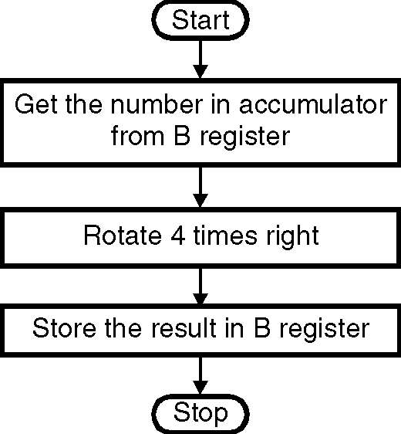
ØØ Program :
Instruction Comment
MOV A,B ; Load the number in
; register A
RAR ; Rotate the number 4 times
; to the right
RAR
RAR
RAR
MOV B,A ; Store the shifted number
HLT ; Terminate program execution Flowchart 26

